**File Change Trigger**

**Summary:**

This document shows how to use **File Change Trigger**.

**Step 1:** Right click on Zap icon and select **Task Editor** or double click on **Zap** icon.

**Step 2:** Drag and Drop **File change Trigger** from activity panel and set the properties.

* **FilePath:**  Enter the path of the file on which user have to set the trigger.
* **FolderPath:** When we set the File Path the folder path will be set automatically.

**NotificationDelay**: Enter time in Milliseconds

**NotifyFilters:** Select the Filter options from drop down menu like Size, Directory Name and so on.

**WatcherChangeType:** Select the watcher Type means trigger will also fire when the file is deleted or moved.

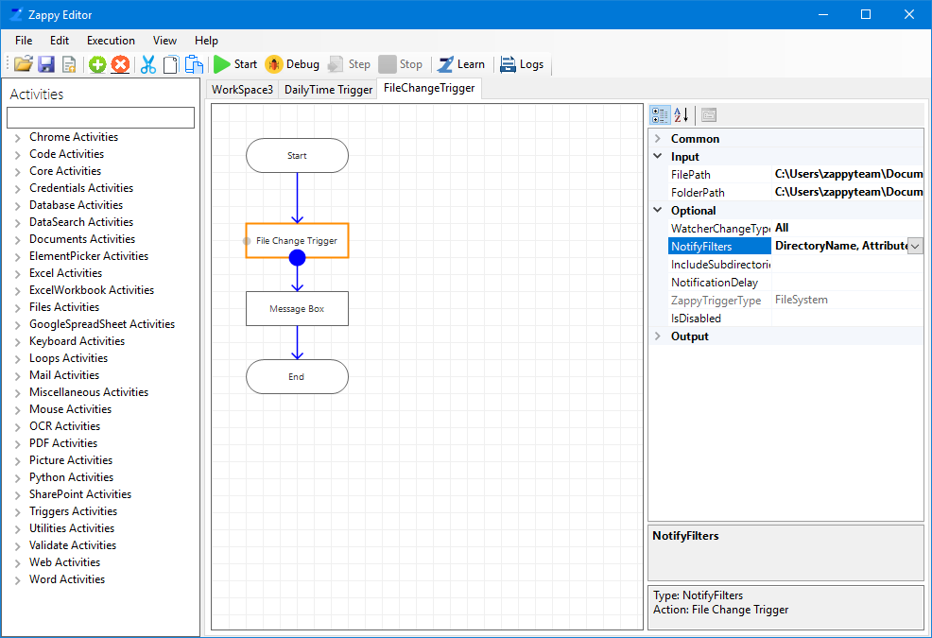

Set file path

In this example we have only shown the message box will display when any changes made in the selected file. We can also add another action / automation flow according to our requirement.

**Step 3:** Click on Start button to register the trigger.

**Step 4:** You will see message “**Successfully Registered Active Trigger**” from Zap.

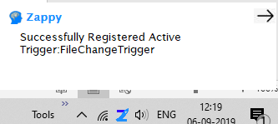

**Step 5:** Whenever user make any changes in file and try to save it, then File Change trigger will fire (Here , we use Zappy.Txt).

